Output for Python program to find prime numbers within a range

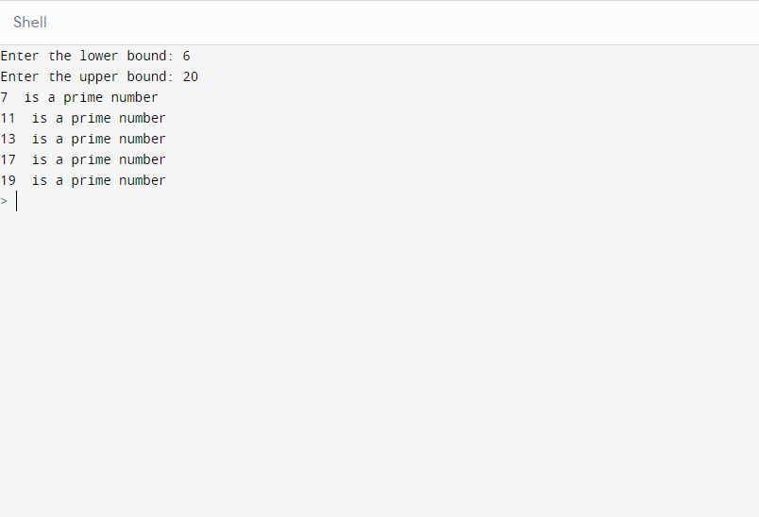

Output for Python program Finding odd numbers in a given range

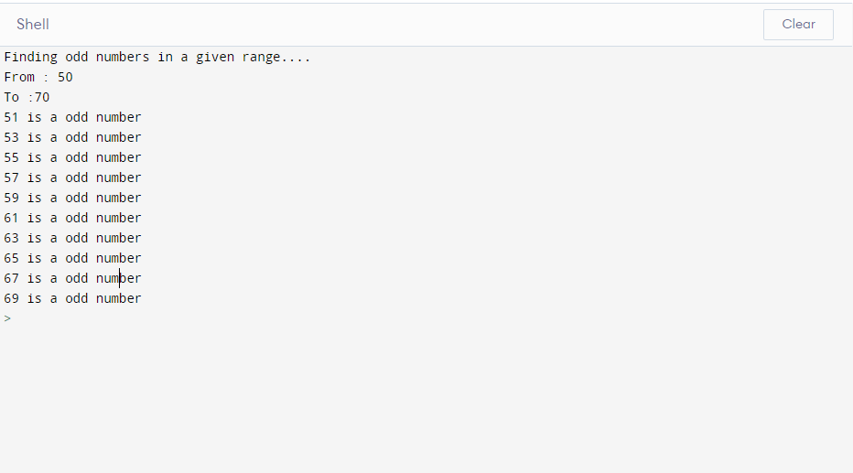

Output for Python program to Finding range of fibonacci numbers

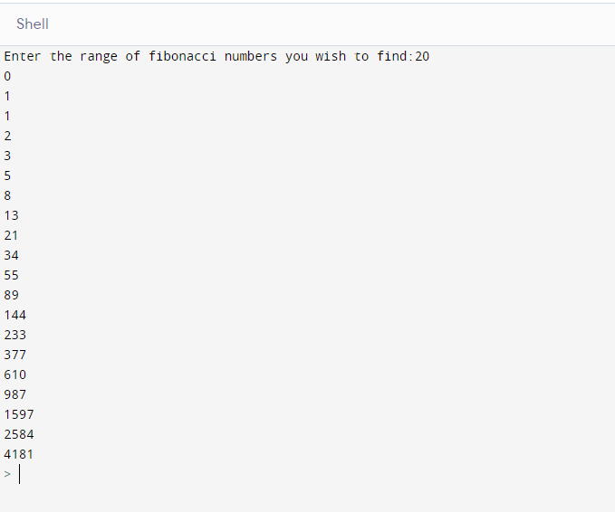

Output for program to check if the given number is a prime number.…

